Invisible Fence® Brand Product Info & Compatibilities
ICT725 Outdoor Transmitter  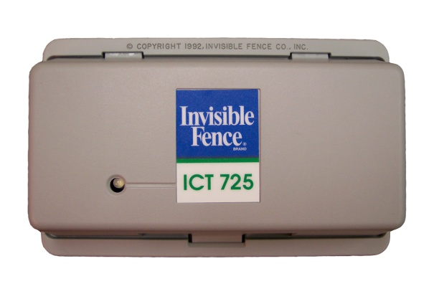  - Platinum Series Product  - Battery Backup Compatible  - Covers up to 12 acres (3000')  Compatibility: A | R21 Platinum Series Receiver  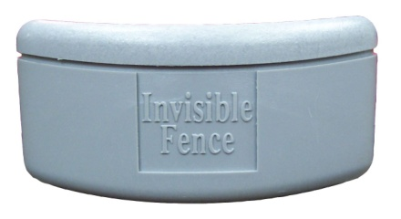  - Weighs 1.6 oz.  - Water resistant  - 7K or 10K Programmable  - Four Static Correction Levels  - Requires PowerCap style battery  Compatibility: A | R5000 Receiver  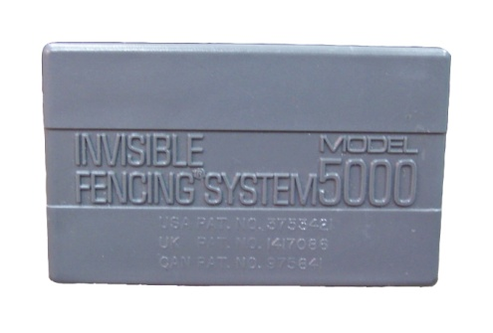  - Original Receiver - Weighs 3.8 oz.  - 7K or 10K, Not Programmable  - One correction level  - Requires 7.5v Silver Oxide Battery  Compatibility: A
ICT700 Outdoor Transmitter  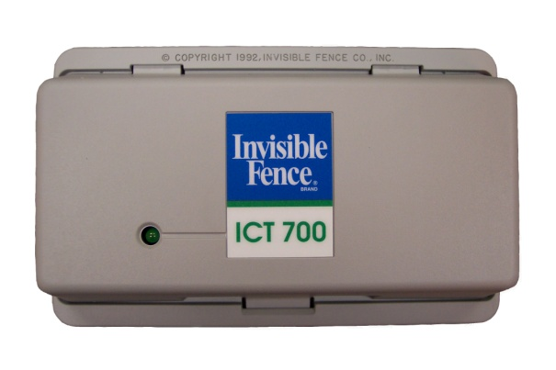  - Platinum Series Product  - 7K or 10K Switchable  - Covers up to 12 acres (3000')  Compatibility: A | Perimeter® ComputerReceiver™  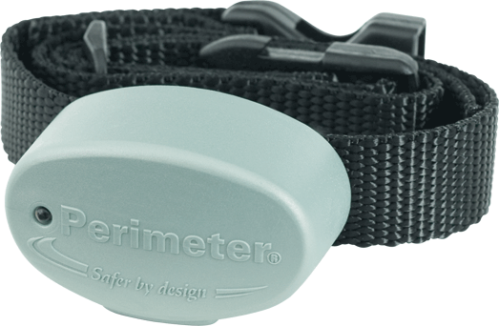  - Weighs 1.1 oz.  - Low Battery Warning Light  - 7K or 10K Programmable  - 4 Static + 1 Prog Corrections  - Requires 6v Lithium Battery  Compatibility: A | R6500 Receiver  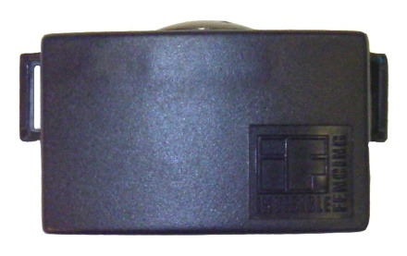  - Weighs 2.7 oz.  - 7K or 10K, Not Programmable  - One correction level  - Requires 7.5v Silver Oxide Battery  Compatibility: A
ICT801 Outdoor Transmitter  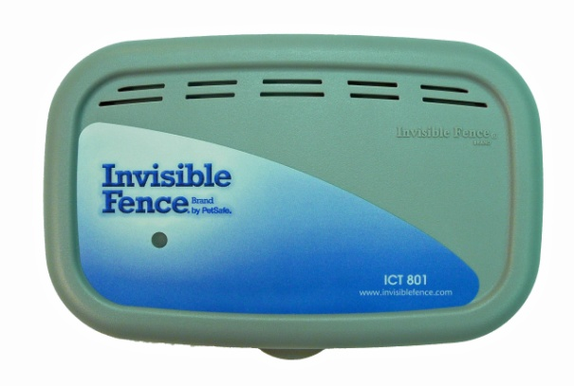  - Titanium Series,  - 7K or 10K, I/O Switchable  - Battery Backup Compatible  - Available w/Dual Loop Capability  Compatibility: B | R21 Titanium Series Receiver  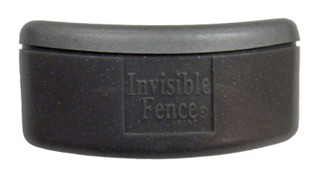  - Weighs 1.6 oz.  - Water resistant  - 7K/10K, I/O Programmable  - Newer version, more options  - Requires PowerCap style battery  Compatibility: B | MicroLite™ Receiver  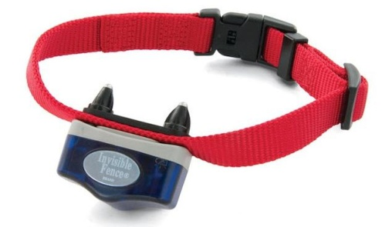  - Weighs 1.0 oz., Waterproof  - 7K/10K, I/O Programmable  - Functions same as Titanium R21  - Requires PowerCap style battery  - Colorful removable 'skins'  Compatibility: A or B
ICT150 Outdoor Transmitter  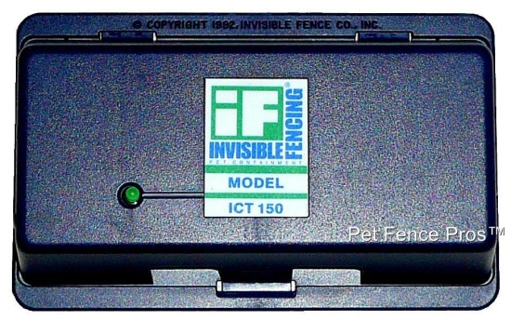  - Similar Predecessor of ICT700  - 7K or 10K Switchable  - Covers up to 12 acres (3000')  - ICT100/100A are Non-switchable  Compatibility: A | R21 Mink Series Receiver  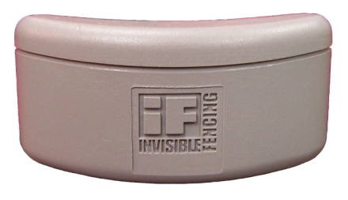  - Weighs 1.6 oz.  - Water resistant  - 7K or 10K Programmable  - Older version, fewer options  - Requires PowerCap style battery  Compatibility: A | LP3000 Loop Lightning Protector  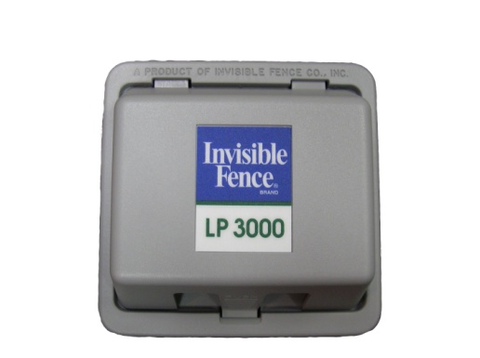  - Identical to older Blue Version  - Protects Boundary Loop only  Compatibility: U
Invisible Gate Outdoor Transmitter  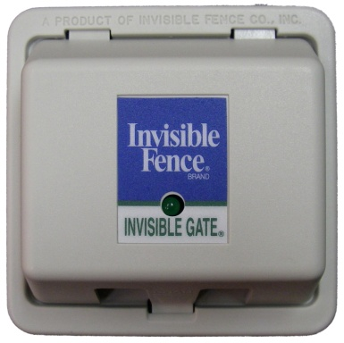  - Similar to ICT75  - 7K or 10K Switchable  - Covers up to ~1/2 acre (500')  Compatibility: A | R21 Graphite Series Receiver  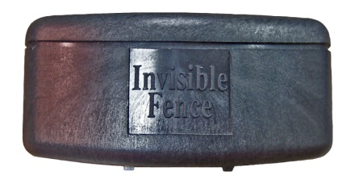  - Weighs 1.6 oz.  - Water resistant  - 7K or 10K Programmable  - Same as Platinum, Less Warranty  - Requires PowerCap style battery  Compatibility: A | LP4100 Lightning & Surge Protector  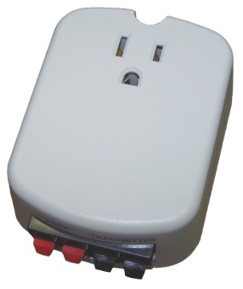  - Identical to Innotek Version  - Protects Boundary Loop & Power Supply  Compatibility: U
ICT750 (250) Outdoor Transmitter  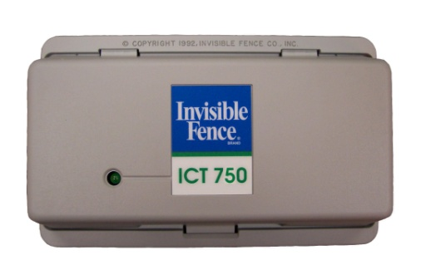  - Platinum Series, 7K or 10K Switch  - Battery Backup Compatible  - Dual Independent Loop Capable  Compatibility: A | R51 Platinum Series Receiver  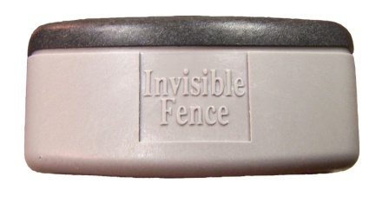  - Weighs 1.6 oz.  - Water resistant  - 7K or 10K Programmable  - For use with stubborn pets  - Requires PowerCap style battery  Compatibility: A | Battery Backup Unit  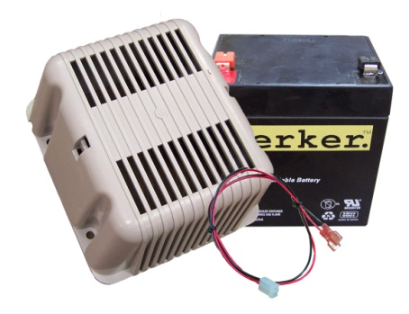  - Houses 12v Rechargeable Battery  - Includes Wiring Harness  Compatibility: I
ICT775 Outdoor Transmitter  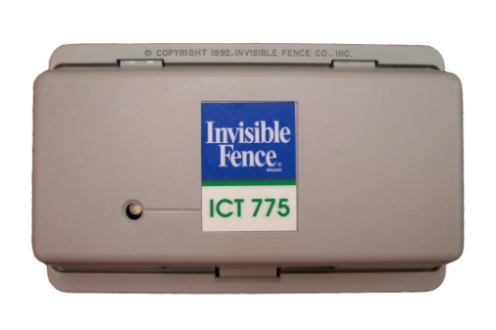  - Platinum Series, 7K Only  - Battery Backup Compatible  - For Large Yards (up to 35 acres)  - 3-Sided Loop Capable  Compatibility: A | IFA12 Indoor Avoidance Unit  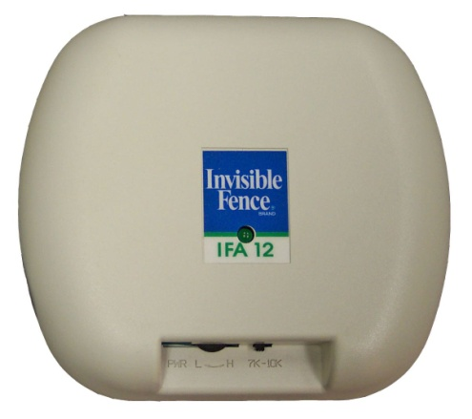  - 7K or 10K Switchable  - Must be plugged in to A/C power  - Range Adjustable to ~6' Radius  Compatibility: A | Shields™ Indoor Avoidance Unit  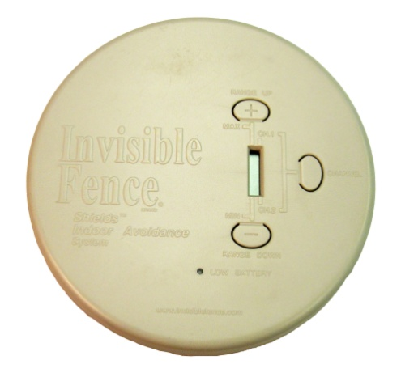  - 7K or 10K, Indoor/Outdoor Switchable  - Battery Operated (rechargeable)  - Range Adjustable to ~6' Radius  Compatibility: B
COMPATIBILITY DESIGNATIONS AND NOTES:
- A – Compatibility Group includes all Invisible Fence brand 100 or 700 series outdoor transmitters, as well as all R21/R51/A12 Receivers except the Titanium versions. Fully compatible with the Perimeter ComputerReceiver. Not compatible with 800 series outdoor transmitters or Shields Indoor units. Further Note: This group is also compatible with Pet Stop® brand pet fence equipment, using Pet Stop’s firmware programming settings. Only the IFA12 in this group is incompatible with Pet Stop receivers.
- B – Compatibility Group includes 800 series outdoor transmitters, R21 Titanium receivers, MicroLite™ receiver, and Shields™ Indoor units. Not compatible with 100 or 700 series outdoor transmitters or IFA12 Indoor unit, or Perimeter ComputerReceiver, or Pet Stop brand transmitters and receivers.
- I – Compatibility Group includes all Invisible Fence brand outdoor transmitters with internal battery backup circuitry. These include the ICT725, ICT250/750, ICT775, and ICT801/802.
- U – Compatibility Group includes all wired pet containment transmitters, including all brands.
– Will accept either the Perimeter brand R21 Replacement battery (formerly Pet Stop brand) or the Invisible Fence brand Powercap battery. (The uncommon Invisible Fence brand R22 receiver, which is larger than the R21, will accept only the Invisible Fence brand Powercap battery and not the Perimeter brand version.)
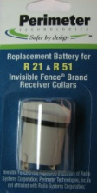
ALL Invisible Fence brand receivers are also compatible with any Perimeter brand Contact Posts.
InvisibleFenceCompatible.com

